

**Music Data Scraping**

**Submitted By:**

**Group Number: 43**

**Muhammad Afzal, 2020-CS-31**

**Muhammad Mohid, 2020-CS-44**

**Submitted To:**

**Mr. Samyan Qayyum Wahla**

**For Fulfillment of**

**CS-261 Data Structures and Algorithms**

**Department of Computer Science**

**University of Engineering and Technology, Lahore**

**Table of Contents**

1. **Overview………………………………………………………………... 2**

* Description………………………………………………………...………. 2
* Motivation………………………………………………...……………...... 2
* Target Audience…………………………………………………...………. 2
* Business Need……………………………………………...……….……... 2

1. **Data……………………………………………………………………... 3**

* Source of scraping…………………………………………………………. 3
* Attributes…………………………………………………………………... 3

1. **Algorithms……………………………………………………………… 4**

* Sorting Algorithms………………………………………………………… 4
* Searching Algorithms……………………………………………………. 27

1. **UI………………………………………………………………………. 30**

* UI using Pencil Tool……………………………………………………... 30
* Components................................................................................................ 30
* Final UI implementation............................................................................. 31

1. **Integration.............................................................................................. 32**

* Problems while Integration......................................................................... 32
* Overview of the whole working................................................................. 32

1. **Collaboration......................................................................................... 33**

**1. Overview**

**Description:**

We are going to create a desktop application which is going to extract data from a music website and save it into a CSV file in different types like Song name, Artist Name, Views, Likes, Comments, Reposts, Release Date and Genre. Our scraping function will have the option to pause at any moment, stop at any time and then continue scraping. We are going to use python as our high-level language for programming and we are using the PyQT module to design our user interface. Every instance of the song will contain different attributes like views, likes etc, in **integer** or song name, artist name, etc in **string**. After we have saved the data into the CSV file, we will read data from the file and we will have 11 different sorting options to sort the instances of songs from smallest to largest (ascending order) or largest to smallest (descending order). We will use different sorting algorithms like merge sort, insertion sort, selection sort, bubble sort, etc. Talking about the interface, the interface will have the option for searching each column. End users will have the option to search using composite filters such as AND, OR and NOT. There will be a progress bar that will indicate the progress of scraping of a particular website.

**Motivation:**

We want to create an app which stores the data of music which almost everyone is into so it can attract a lot of clients.

**Target Audience:**

We are going to target everyone in the Music Industry and also music software developers.

**Business Need:**

We will be able to sort and search from the scraped data. Everyone in the Music Industry and new music software developers will be able to benefit from this project. They can see which kind of data they want to put in.

**2. Data**

**Source of Scraping:**

We used SoundCloud as a source of scraping, which is a music streaming platform.



Figure : SoundCloud Main Screen

**Attributes:**

We scraped songs with the following attributes from the website and are marked in the Figure 2 below:

1. Song Name
2. Artist Name
3. Views
4. Likes
5. Comments
6. Reposts
7. Release Date
8. Genre

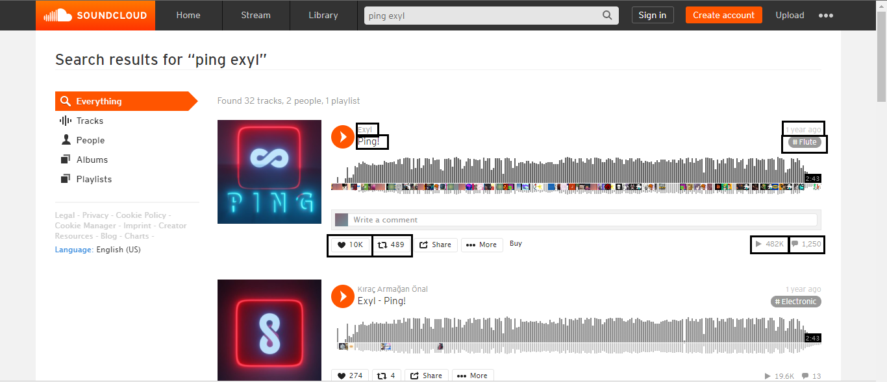

Figure : Marked Attributes on website

**3. Algorithms**

**Sorting Algorithms:**

**Merge Sort:**

Merge sort divides the input array into two arrays and does it recursively until their size is 1 and then compares every index with each other for sorting.

**Pseudo Code:**

Merge(A, p, q, r)

n1 = q - p + 1

n2 = r - q

let L[1…n1+1] and R[1…n2+1] be new arrays

**for** i = 1 **to** n1

L[i] = A[p + i - 1]

**for**  j = 1 **to** n2

R[j] = A[q + j]

L[n1 + 1] = ∞

R[n2 + 1] = ∞

i = 1

j = 1

**for** k = p **to** r

**if** L[i] <= R[j]

A[k] = L[i]

**else** A[k] = R[j]

j = j + 1

**Code:**

def merge(self, A, start, mid, end):

        index1 = mid - start + 1

        index2 = end - mid

        left = []

        right= []

        for i in range(0,index1):

            left.append(A[start + i])

        for j in range(0,index2):

            right.append(A[mid + j + 1])

        left.append(math.inf)

        right.append(math.inf)

        i = 0

        j = 0

        for k  in range(start,end+1):

            if left[i] <= right[j]:

                A[k] = left[i]

                i += 1

            else:

                A[k] = right[j]

                j += 1

    def merge_sort(self, A, start, end):

        if start < end:

            mid = int((start + end)/2)

            self.merge_sort(A, start, mid)

            self.merge_sort(A, mid+1, end)

            self.merge(A, start, mid, end)

**Time Complexity:**

Time Complexity of merge sort is **O(n*lg(n))** in all worst average and best cases.

**Proof of Correctness:**

**Initialization:** Before the first iteration of the loop, we have k=p, so the subarray A is empty. This subarray contains the smallest elements of k-p=0, since i and j both = 0 therefore L[i] and R[j] both are smallest element of the array which have not yeh copied in A.

**Maintenance:** To check that each iteration maintains the loop invariant, we assume that L[i] <= R[j], then L[i] is the smallest element not yet copied. After that the subarray A will contain the smallest elements. After the incrementing of the loop, it reestablishes the loop invariant.

**Termination:** As for the loop invariant termination will be at k=r+1, after that the subarray A contains the largest elements of both L and R merged arrays.

**Strengths:**

* It is Faster for larger inputs.
* It uses a consistent running time
* It uses a divide and conquer principle which splits the array into half.

**Weaknesses:**

* Slower with smaller inputs.
* It goes through the whole procedure even when the list is almost sorted.
* Uses more memory.

**Dry Run:**

Unsorted Array: [7, 6, 5, 65, 34]

------------

Partitioned: 7 6

Right: [6, inf]

Left: [7, inf]

Merged: [6, 7, 5, 65, 34]

------------

Partitioned: 6 7 5

Right: [5, inf]

Left: [6, 7, inf]

Merged: [5, 6, 7, 65, 34]

------------

Partitioned: 65 34

Right: [34, inf]

Left: [65, inf]

Merged: [5, 6, 7, 34, 65]

------------

Partitioned: 5 6 7 34 65

Right: [34, 65, inf]

Left: [5, 6, 7, inf]

Merged: [5, 6, 7, 34, 65]

------------

Sorted Array: [5, 6, 7, 34, 65]

**Insertion Sort:**

Insertion sort starts from a single index and then goes to next indexes comparing adjacent indexes and sorting.

**Pseudo Code:**

for i = 1 to n

key ← A [i]

j ← i – 1

while j > = 0 and A[j] > key

A[j+1] ← A[j]

 j ← j – 1

End while

A[j+1] ← key

End for

**Code:**

def perform_sorting(self, array: List):

        for idx in range(1,len(array)):

            key = array[idx]

            i = idx-1

            while i >= 0 and array[i] > key:

                array[i+1] = array[i]

                i = i - 1

            array[i+1] = key

        return array

**Time Complexity:**

Time Complexity of insertion sort is **O(n2)** for worst and average cases and for best case it is **O(n)**.

**Proof of Correctness:**

**Initialization:** Before the first iteration of the loop the subarray A will have unsorted elements of the array, the loop invariant is satisfied at the beginning of the loop.

**Maintenance:** If the loop invariant is true at start, then body of loop works by checking the next element of the array A[j-1], A[j-2], A[j-3] and compares it with the rest of the array that it has sorted and then increment itself to the next element.

**Termination:** As for the loop invariant termination will be at j>n, after that the subarray A will be sorted.

**Strengths:**

* Simple to understand.
* It performs well for small input.
* It takes very less space.

**Weaknesses:**

* It is slower with time of O(n2).
* It performs bad for large inputs.
* It is a lot slower for reverse sorted input.

**Dry Run:**

Unsorted Array: [6, 0, 20, 5]

------------

Index changed before loop: 0

Index changed in loop: -1

Sorted array till now: [6, 6, 20, 5]

------------

Key: 0

Index changed before loop: 1

Key: 20

Index changed before loop: 2

Index changed in loop: 1

Sorted array till now: [0, 6, 20, 20]

------------

Index changed in loop: 0

Sorted array till now: [0, 6, 6, 20]

------------

Key: 5

------------

Sorted Array: [0, 5, 6, 20]

**Selection Sort:**

Selection sorts an array by finding the minimum (or maximum) value and putting it in the start of the new array.

**Pseudo Code:**

for i = 1 to n - 1

min = i

for j = i+1 to n

if list[j] < list[min] then

min = j;

end if

end for

if indexMin != i then

swap list[min] and list[i]

end if

end for

**Code:**

def perform_sorting(self, array: List):

        for outer in range(0, len(array)):

            min = outer

            for inner in range(outer+1, len(array)):

                if array[inner] < array[min]:

                        min= inner

            temp = array[outer]

            array[outer] = array[min]

            array[min] = temp

        return array

**Time Complexity:**

Time Complexity of Insertion Sort is **O(n2)** for all best, worst and average cases.

**Proof of Correctness:**

**Initialization:** Before the first iteration of the loop, the subarray A will have unsorted elements of the array, the line will set min to 1, also the loop invariant will be satisfied at the beginning of the loop.

**Maintenance:** If the loop invariant is true at start, then body of loop works by checking the condition and storing the smallest element of the array at A[j] and then increment itself to the next element.

**Termination:** As for the loop invariant termination will be at j=n+1, after that the subarray A will be sorted.

**Strengths:**

* It performs well for small inputs.
* No additional temporary storage is required.
* Arrangements of data does not affect its performance.

**Weaknesses:**

* It is slower in time with O(n2).
* It doesn’t perform good with large inputs.
* It will take the same time even if the array is almost sorted.

**Dry Run:**

Unsorted Array: [11, 10, 8, -1]

------------

Supposed minimum: 0

Actual minimum: 1

Actual minimum: 2

Actual minimum: 3

Sorted array till now: [-1, 10, 8, 11]

Supposed minimum: 1

Actual minimum: 2

Sorted array till now: [-1, 8, 10, 11]

Supposed minimum: 2

Sorted array till now: [-1, 8, 10, 11]

Supposed minimum: 3

Sorted array till now: [-1, 8, 10, 11]

------------

Sorted Array: [-1, 8, 10, 11]

**Bubble Sort:**

Bubble sort works by adjacently swapping the adjacent elements by checking the condition.

**Pseudo Code:**

bubbleSort( list : array of items )

loop = list.count;

for i = 0 to loop-1 do:

swapped = false

for j = 0 to loop-1 do:

if list[j] > list[j+1] then

swap( list[j], list[j+1] )

swapped = true

end if

**Code:**

     def perform_sorting(self, array: List):

        n = len(array)

        for outer in range(0,n):

            for inner in range(0,n-outer-1):

                if(array[inner] > array[inner + 1]):

                    temp = array[inner]

                    array[inner] = array[inner+1]

                    array[inner+1] = temp

        return array

**Time Complexity:**

Time Complexity of Bubble Sort is **O(n2)** for worst and average cases and **O(n)** for best case.

**Proof of Correctness:**

**Initialization:** Before the first iteration of the loop, the array will have unsorted elements of the array and the loop invariant will be satisfied at the beginning of the loop.

**Maintenance:** If the loop invariant is true at start, then body of loop checks the adjacent elements of the array array[i], array[i+1] and swapping them if the condition is true array[i]>array[i+1], and then increment itself to the next element.

**Termination:** As for the loop invariant termination will be at i=A.length, after that the array will be sorted.

**Strengths:**

* Easy to understand.
* Easy to implement.
* Doesn’t take large amount of memory.

**Weaknesses:**

* It is slower with time of O(n2).
* It doesn’t perform well with large inputs.
* Adjacent swapping makes it a lot slower for reverse sorted input.

**Dry Run:**

Unsorted Array: [11, 52, 8, -1]

------------

Alternative one Index: 0

Alternative two Index: 0

Alternative two Index: 1

Alternative two Index: 2

Sorted array till now: [11, 8, -1, 52]

Alternative one Index: 1

Alternative two Index: 0

Alternative two Index: 1

Sorted array till now: [8, -1, 11, 52]

Alternative one Index: 2

Alternative two Index: 0

Sorted array till now: [-1, 8, 11, 52]

Alternative one Index: 3

Sorted array till now: [-1, 8, 11, 52]

------------

Sorted Array: [-1, 8, 11, 52]

**Quick Sort:**

Quick sort chooses an element as pivot and then compares the element, the element which is smaller than pivot goes to its left and vice versa, and does this recursively.

**Pseudo Code:**

quickSort(arr[], low, high)

if (low < high)

pi = partition(arr, low, high)

quickSort(arr, low, pi - 1)

quickSort(arr, pi + 1, high)

partition(arr[], low, high)

pivot = arr[high]

i = (low - 1)

            for (j = low; j <= high- 1; j++)

if (arr[j] < pivot)

 i++

swap arr[i] and arr[j]

swap arr[i + 1] and arr[high])

return (i + 1)

**Code:**

    def Partition(self, array, low, high):

        pivot = array[high]

        i = low - 1

        for idx in range(low, high):

            if array[idx] < pivot:

                i+=1

                temp = array[i]

                array[i] = array[idx]

                array[idx] = temp

        temp = array[i+1]

        array[i+1] = array[high]

        array[high] = temp

        return i+1

    def quick_sort(self, array, low, high):

        if low < high:

            pivot = self.Partition(array, low, high)

            self.quickSort(array, low, pivot - 1)

            self.quickSort(array, pivot + 1, high)

**Time Complexity:**

Time Complexity of Quick Sort is O(n2) for worst case and O(n*lg(n)) for best and average case.

**Proof of Correctness:**

**Initialization:** Before the first iteration of the loop, i = p-1 and j = p with this the first two conditions of loop invariant will be satisfied.

**Maintenance:** If the loop invariant is true at start, then j is incremented and according to the pivot the array is formed and the elements will be swapped according arr[j] < pivot and by using recursion it is maintained.

**Termination:** As for the loop invariant termination will be at j = r, after that the array will be sorted.

**Strengths:**

* It is efficient.
* No additional storage is required.
* It performs well for large inputs

**Weaknesses:**

* It is not stable.
* It worst case is slower with time complexity of O(n2).
* It is recursive.

**Dry Run:**

Unsorted Array: [13, 22, 8, 14]

------------

Pivot: 14

Sorted array till now: [13, 22, 8, 14]

Sorted array till now: [13, 8, 22, 14]

Sorted array till now: [13, 8, 14, 22]

Pivot: 8

Sorted array till now: [8, 13, 14, 22]

------------

Sorted Array: [8, 13, 14, 22]

**Heap Sort:**

Heap sort selects the largest element of the array from the unsorted side and then puts it in the sorted array.

**Pseudo Code:**

Heapsort(A)

   BuildHeap(A)

   for i <- length(A) downto 2 {

      exchange A[1] <-> A[i]

      heapsize <- heapsize -1

      Heapify(A, 1)

BuildHeap(A)

   heapsize <- length(A)

   for i <- floor( length/2 ) downto 1

      Heapify(A, i)

Heapify(A, i)

   le <- left(i)

   ri <- right(i)

   if (le<=heapsize) and (A[le]>A[i])

      largest <- le

   else

      largest <- i

   if (ri<=heapsize) and (A[ri]>A[largest])

      largest <- ri

   if (largest != i) {

      exchange A[i] <-> A[largest]

      Heapify(A, largest)

**Code:**

def heapify(self, array, n, i):

        max_num = i

        left = 2 * i + 1

        right = 2 * i + 2

        if left < n and array[i] < array[left]:

            max_num = left

            if right < n and array[max_num] < array[right]:

                max_num = right

            if max_num != i:

                array[i], array[max_num] = array[max_num], array[i]

                self.heapify(array, n, max_num)

    def heapSort(self, array):

        n = len(array)

        for idx in range(n // 2 - 1, -1, -1):

            self.heapify(array, n, idx)

            for i in range(n-1, 0, -1):

                array[i], array[0] = array[0], array[i]

                self.heapify(array, i, 0)

**Time Complexity:**

Time Complexity of Heap sort is **O(n*lg(n))** in all worst average and best cases.

**Proof of Correctness:**

**Initialization:** Before the first iteration of the loop each node i + 1, i + 2, … n, everything is leaf so it is a heap, so loop invariant will be satisfied.

**Maintenance:** If the loop invariant is true at start, subtrees at children of node I are mac heaps, decrementing i reestablishes the loop invariant for next iteration.

**Termination:** As for the loop invariant termination will be at i = 0, after that the array will be sorted.

**Strengths:**

* It is efficient.
* Its memory usage is minimal.
* It is simple to understand.

**Weaknesses:**

* It’s worse case comes in O(n*lg(n)).
* It is unstable sort.
* Memory management is complex.

**Dry Run:**

Unsorted Array: [13, 22, 66, 14]

------------

Sorted array till now: [13, 22, 66, 14]

Sorted array till now: [66, 22, 14, 13]

Sorted array till now: [66, 22, 14, 13]

Sorted array till now: [22, 14, 66, 13]

Sorted array till now: [22, 14, 66, 13]

Sorted array till now: [14, 22, 66, 13]

Sorted array till now: [66, 22, 14, 13]

Sorted array till now: [66, 22, 14, 13]

Sorted array till now: [22, 13, 14, 66]

Sorted array till now: [22, 13, 14, 66]

Sorted array till now: [14, 13, 22, 66]

Sorted array till now: [13, 14, 22, 66]

------------

Sorted Array: [13, 14, 22, 66]

**Counting Sort:**

In counting sort, we create an array to the highest number found in the array, after that we again check the array and which variable is found in that array in incremented.

**Pseudo Code:**

CountingSort(input)

k = range of elements of array

count ← array of k + 1 zeros

output ← array of same length as input

for i = 0 to length(input) - 1 do

j = key(input[i])

count[j] += 1

for i = 1 to k do

count[i] += count[i - 1]

for i = length(input) - 1 down to 0 do

j = key(input[i])

count[j] -= 1

output[count[j]] = input[i]

return output

**Code:**

def perform_sorting(self, array: List):

        max_var =  max(array)

        min_var =  min(array)

        key = (max_var - min_var) + 1

        counts = []

        output = []

        for idx in range(0 , key):

            counts.append(0)

for i in range(0 ,  len(array)):

            output.append(0)

        for j in range(0 , len(array)):

            k = self.find_key(array[j] , min_var)

            counts[k] += 1

        for a in range(1 , key):

            counts[a] += counts[a-1]

        for i in range(len(array) - 1, -1, -1):

            j = self.find_key(array[i] , min_var)

            counts[j] -= 1

            output[counts[j]] = array[i]

        return output

    def find_key(self, element, min):

        key = (min * -1) + element

        return key

**Time Complexity:**

Time Complexity of Counting sort is **O(n+k)** for best, averaged and worst case.

**Proof of Correctness:**

**Initialization:** Before the first iteration of the loop, we assume an array with the range of its highest to lowest element.

**Maintenance:** Assume the loop invariant is true at start, we create an array with index of range from the highest to lowest element with C[i] = 0 after that we increment the index after we compare from the original array and increment the indexes j = key(input[i]), count[j] += 1 and then start a loop while decrementing the array C from that array and copying the elements in the new array.

**Termination:** As for the loop invariant termination will be at i = 0, after that the array will be sorted.

**Strengths:**

* It is a fast sorting algorithm with time complexity of O(n).
* It is a stable sort.
* It is good for inputs in which the range of array is not too large.

**Weaknesses:**

* It can take a lot of space for many inputs.
* It works bad when the difference of element of input array is quite large.
* It cannot be used for string inputs.

**Dry Run:**

Unsorted Array: [3, 8, 4, 11]

-----------------------------

Counts array: [1, 1, 0, 0, 0, 1, 0, 0, 1]

Traversed Counts array [1, 2, 2, 2, 2, 3, 3, 3, 4]

Sorted array till now: [3, 4, 8, 11]

Counts array after every number sort: [0, 1, 2, 2, 2, 2, 3, 3, 3]

-----------------------------

Sorted Array: [3, 4, 8, 11]

**Radix Sort:**

Radix sort uses digit to digit sorting starting from least significant to most significant digit and then sorts the array.

**Pseudo Code:**

Radix-Sort(A, d)

    for j = 1 to d do

            int count[10] = {0};

            for i = 0 to n do

                count[key of(A[i]) in pass j]++

            for k = 1 to 10 do

                count[k] = count[k] + count[k-1]

            for i = n-1 downto 0 do

                result[ count[key of(A[i])] ] = A[j]

                count[key of(A[i])]--

         for i=0 to n do

                A[i] = result[i]

    end for(j)

 end func

**Code:**

 def countingSort(self, array, place):

        n = len(array)

        counts = []

        output = []

        for idx in range(0 , 10):

            counts.append(0)

        for i in range(0 ,  len(array)):

            output.append(0)

        for i in range(0, n):

            idx = array[i] // place

            counts[idx % 10] += 1

        for i in range(1, 10):

            counts[i] += counts[i - 1]

        for i in range(len(array) - 1, -1, -1):

            index = array[i] // place

            output[counts[index % 10] - 1] = array[i]

            counts[index % 10] -= 1

        for i in range(0, n):

            array[i] = output[i]

    def radixSort(self, array):

        max_elem = max(array)

place = 1

        while max_elem // place > 0:

            self.countingSort(array, place)

            place = place * 10

**Time Complexity:**

Time Complexity for radix sort is **O(n)** for best and average cases and **O(n2)** for worst cases.

**Proof of Correctness:**

**Initialization:** Before the first iteration of the loop, we assume every digit as independent and sorts them independently.

**Maintenance:** Assume the loop invariant is true at start, we create an array and first compare them with their least significant digit and store it into the new array and then move it through by incrementing to most significant digit.

**Termination:** As for the loop invariant termination will be at i = d, after that the array will be sorted.

**Strengths:**

* It is a stable sort.
* It is quite fast with time complexity of O(n).
* It is fast when the range of array is less.

**Weaknesses:**

* It is quite slower for worst case.
* It is very less flexible.
* It takes more space.

**Dry Run:**

Unsorted Array: [6, 15, 4, 7]

-----------------------------

Counts array: [0, 0, 0, 0, 1, 1, 1, 1, 0, 0]

Traversed Counts array [0, 0, 0, 0, 1, 2, 3, 4, 4, 4]

Sorted array till now: [4, 15, 6, 7]

Counts array after every number sort: [0, 0, 0, 0, 0, 1, 2, 3, 4, 4]

-----------------------------

Counts array: [3, 1, 0, 0, 0, 0, 0, 0, 0, 0]

Traversed Counts array [3, 4, 4, 4, 4, 4, 4, 4, 4, 4]

Sorted array till now: [4, 6, 7, 15]

Counts array after every number sort: [0, 3, 4, 4, 4, 4, 4, 4, 4, 4]

Sorted Array: [4, 6, 7, 15]

**Bucket Sort:**

Bucket sort distributes the elements of the array into a number of buckets and then uses a different sorting algorithm to sort each bucket.

**Pseudo Code:**

function bucketSort(array, k) is

buckets ← new array of k empty lists

M ← the maximum key value in the array

for i = 1 to length(array) do

     insert *array[i]* into *buckets[floor(k × array[i]/M)]*

for i = 1 to k do

     nextSort(buckets[i])

return the concatenation of buckets[1], ...., buckets[k]

**Code:**

def perform_sorting(self, array: List):

        bucket = []

        for idx in range(0,10):

            bucket.append([])

        for element in array:

            index = math.floor(element*10)

            bucket[index].append(element)

        for bucketIDX in range(0 , len(bucket)):

            bucket[bucketIDX] = InsertionSort.insertion_sort(bucket[bucketIDX])

        original_idx = 0

        for bucketidx in range(0 , len(bucket)):

            for idx in range(0 , len(bucket[bucketidx])):

                array[original_idx] = bucket[bucketidx][idx]

                original_idx += 1

        return array

**Time Complexity:**

Time Complexity for Bucket sort is **O(n)** for best and average case and **O(n2)** for worst case**.**

**Proof of Correctness:**

**Initialization:** Before the first iteration of the loop, we assume arrays as buckets.

**Maintenance:** Assume the loop invariant is true at start, we create an array with indexes from 0 to 9 after that we put the values by using their most significant bit into those assumed arrays and sort those arrays using any different sorting algorithms and then sort accordingly.

**Termination:** As for the loop invariant termination will be at i = n-1, after that the array will be sorted.

**Strengths:**

* It is efficient.
* It is stable.
* It takes less memory.

**Weaknesses:**

* It is quite slower for worst case.
* It doesn’t work good for array with close range elements.
* It is less flexible.

**Dry Run:**

Unsorted Array: [0.667, 0.529, 0.566, 0.424, 0.205, 0.3124]

Bucket: []

Bucket: []

Bucket: [0.205]

Bucket: [0.3124]

Bucket: [0.424]

Bucket: [0.529, 0.566]

Bucket: [0.667]

Bucket: []

Bucket: []

Bucket: []

Buckets: [0.205, 0.529, 0.566, 0.424, 0.205, 0.3124]

Buckets: [0.205, 0.3124, 0.566, 0.424, 0.205, 0.3124]

Buckets: [0.205, 0.3124, 0.424, 0.424, 0.205, 0.3124]

Buckets: [0.205, 0.3124, 0.424, 0.529, 0.205, 0.3124]

Buckets: [0.205, 0.3124, 0.424, 0.529, 0.566, 0.3124]

Buckets: [0.205, 0.3124, 0.424, 0.529, 0.566, 0.667]

Sorted Array: [0.205, 0.3124, 0.424, 0.529, 0.566, 0.667]

**Gnome Sort:**

Gnome sort works with a single element at a time and then places it to its proper place by a number of swaps.

**Pseudo Code:**

procedure optimizedGnomeSort(a[]):

for pos in 1 to length(a):

     gnomeSort(a, pos)

procedure gnomeSort(a[], upperBound):

pos := upperBound

while pos > 0 and a[pos-1] > a[pos]:

     swap a[pos-1] an

**Code:**

def perform_sorting(self, array: List):

        n = len(array)

        idx = 0

        while idx < n:

            if idx == 0:

                idx +=1

            elif array[idx] >= array[idx-1]:

                idx +=1

            else:

                array[idx] , array[idx - 1] = array[idx- 1] , array[idx]

                idx -=1

        return array

**Time Complexity:**

Time Complexity for gnome sort is **O(n2)** for all worst and average cases but **O(n)** for best case.

**Proof of Correctness:**

**Initialization:** Before the first iteration of the loop, we assume the elements by putting it to its right place by swapping.

**Maintenance:** Assume the loop invariant is true at start, we check the elements by their index with each other and by putting it to the its right place. After the incrementing of the loop, it reestablishes the loop invariant.

**Termination:** As for the loop invariant termination will happen when index < n is false, after that the array will be sorted.

**Strengths:**

* It is easy to understand.
* It is stable.
* It simply moves by swapping the adjacent elements.

**Weaknesses:**

* It worst and average case time is quite slow.
* It is similar to bubble sort.
* It is less flexible.

**Dry Run:**

Unsorted Array: [9, 1, 0, 3]

Index: 0

Index: 1

Sorted array till now: [9, 1, 0, 3]

-----------------------------

Index: 0

Sorted array till now: [1, 9, 0, 3]

-----------------------------

Index: 1

Sorted array till now: [1, 9, 0, 3]

-----------------------------

Index: 2

Sorted array till now: [1, 9, 0, 3]

-----------------------------

Index: 1

Sorted array till now: [1, 0, 9, 3]

-----------------------------

Index: 0

Sorted array till now: [0, 1, 9, 3]

-----------------------------

Index: 1

Sorted array till now: [0, 1, 9, 3]

-----------------------------

Index: 2

Sorted array till now: [0, 1, 9, 3]

-----------------------------

Index: 3

Sorted array till now: [0, 1, 9, 3]

-----------------------------

Index: 2

Sorted array till now: [0, 1, 3, 9]

-----------------------------

Index: 3

Sorted array till now: [0, 1, 3, 9]

-----------------------------

Index: 4

Sorted array till now: [0, 1, 3, 9]

-----------------------------

Sorted Array: [0, 1, 3, 9]

**Shell Sort:**

Shell sort sorts the elements far from each other, then progressively reduces the gap between the elements to be compared.

**Pseudo Code:**

procedure shellSort()

   A : array of items

   while interval < A.length /3 do:

   interval = interval * 3 + 1

   end while

   while interval > 0 do:

   for outer = interval; outer < A.length; outer ++ do:

   valueToInsert = A[outer]

   inner = outer;

      while inner > interval -1 && A[inner - interval] >= valueToInsert do:

            A[inner] = A[inner - interval]

            inner = inner - interval

      end while

   A[inner] = valueToInsert

   end for

   interval = (interval -1) /3;

   end while

end procedure

**Code:**

def perform_sorting(self, array: List):

        gap = int(len(array)/2)

        while gap > 0:

            i = 0

            inner = gap

            while inner < len(array):

                if array[i] > array[inner]:

                    array[i], array[inner] = array[inner], array[i]

                i += 1

                inner += 1

                idx = i

                while idx - gap  > -1:

                    if array[idx - gap] > array[idx]:

                        array[idx - gap], array[idx] = array[idx], array[idx-gap]

idx -= 1

            gap = int(gap / 2)

        return array

**Time Complexity:**

Time complexity of shell sort is **O(n*lg(n))** for best and average case and **O(n2)** for worst case.

**Proof of Correctness:**

**Initialization:** Before the first iteration of the loop, we assume the elements which are far from each other and then reduces dynamically.

**Maintenance:** Assume the loop invariant is true at start, we check the elements by their indexes which and sort those which are far from each other k - gap > -1 by using this condition we swap the values which are not in the right order.

**Termination:** As for the loop invariant termination will happen when gap <= 0, after that the array will be sorted.

**Strengths:**

* It does not require extra space.
* It is only efficient for finite number of elements.
* Its average case is also quite faster.

**Weaknesses:**

* It is complex and difficult to understand.
* It is not stable.
* Its worst-case scenario is quite slow.

**Dry Run:**

Unsorted Array: [13, 22, 8, 14]

------------

Gap: 2

Sorted array till now: [8, 22, 13, 14]

Sorted array till now: [8, 14, 13, 22]

Sorted array till now: [8, 14, 13, 22]

Gap: 1

Sorted array till now: [8, 14, 13, 22]

Sorted array till now: [8, 14, 13, 22]

Sorted array till now: [8, 13, 14, 22]

Sorted array till now: [8, 13, 14, 22]

Sorted array till now: [8, 13, 14, 22]

Sorted array till now: [8, 13, 14, 22]

Sorted array till now: [8, 13, 14, 22]

Sorted array till now: [8, 13, 14, 22]

Sorted array till now: [8, 13, 14, 22]

Gap: 0

------------

Sorted Array: [8, 13, 14, 22]

**Searching Algorithms:**

**Linear Search:**

Linear search uses a simple technique by checking every element of the list from start to end or vice versa (as the used condition) and return the value when the element is found.

**Pseudo Code:**

procedure linear_search (list, value)

for each item in the list

if match item == value

return the item's location

end if

end for

end procedure

**Code:**

def linearSearch(arr, n, x):

for i in range(0, n):

if (arr[i] == x):

return i

return -1

**Time Complexity:**

Time Complexity of Binary search is **O(n)** for all worst and average cases and **O(1)** for best case.

**Proof of Correctness:**

**Initialization:** Before the first iteration of the loop, the array will be empty and empty array cannot contain the element to be searched.

**Maintenance:** Assume the loop invariant is true at start, we check every element by using a loop and in it the condition will check if the ata the given index of the list the element is present or not.

**Termination:** As for the loop invariant termination will happen when arr[i] == x, after that we would have found the searched element.

**Strengths:**

* It is efficient.
* It is faster for finite number of elements.
* It is easy to understand.

**Weaknesses:**

* It is slow for a larger array.
* Its worst-case scenario is slow.
* It needs more space.

**Dry Run:**

Array: [13, 22, 8, 14]

Suppose we have to find 8

------------

Array till now: [**13**, 22, 8, 14]

Array till now: [13, **22**, 8, 14]

Array till now: [13, 22, **8**, 14]

------------

8 is found at index 2

**Binary Search:**

Binary searches simply divide the array into half and goes to the middle element and check whether the number is smaller greater or at that same place and calls itself recursively according to the given array (**Note:** It is necessary for the array to be sorted before starting the binary search).

**Pseudo Code:**

binarySearch(arr, item, beg, end)

if beg<=end

midIndex = (beg + end) / 2

if item == arr[midIndex]

return midIndex

else if item < arr[midIndex]

return binarySearch(arr, item, midIndex + 1, end)

else

return binarySearch(arr, item, beg, midIndex - 1)

return -1

**Code:**

def binarySearch (arr, l, r, x):

if r >= l:

mid = l + (r - l) // 2

if arr[mid] == x:

return mid

elif arr[mid] > x:

return binarySearch(arr, l, mid-1, x)

else:

return binarySearch(arr, mid + 1, r, x)

else:

return -1

**Time Complexity:**

Time Complexity of Binary search is **O(logn)** for all worst and average cases and **O(1)** for best case.

**Proof of Correctness:**

**Initialization:** Before the first iteration of the loop, the array will be empty and empty array cannot contain the element to be searched.

**Maintenance:** Assume the loop invariant is true at start, we check the element by dividing the array into half, if that is the element to be found then we return the value otherwise we recursively call the function to left or right (depending upon if it is larger or smaller) again and again until we found the element.

**Termination:** As for the loop invariant termination will happen when arr[mid] == x, after that we would have found the searched element.

**Strengths:**

* It is efficient.
* It is faster than many search algorithms.
* It is easy to understand.

**Weaknesses:**

* It is recursive.
* It requires that array is sorted.
* It requires more stack power.

**Dry Run:**

Array: [4, 7, 10, 12, 25]

Suppose we have to find 12

------------

Array till now: [4, 7, **10**, 12, 25]

Array till now: [4, 7, 10, **12**, 25]

------------

12 is found at index 4

**4. User Interface**

**UI using Pencil Tool (Wireframe)**

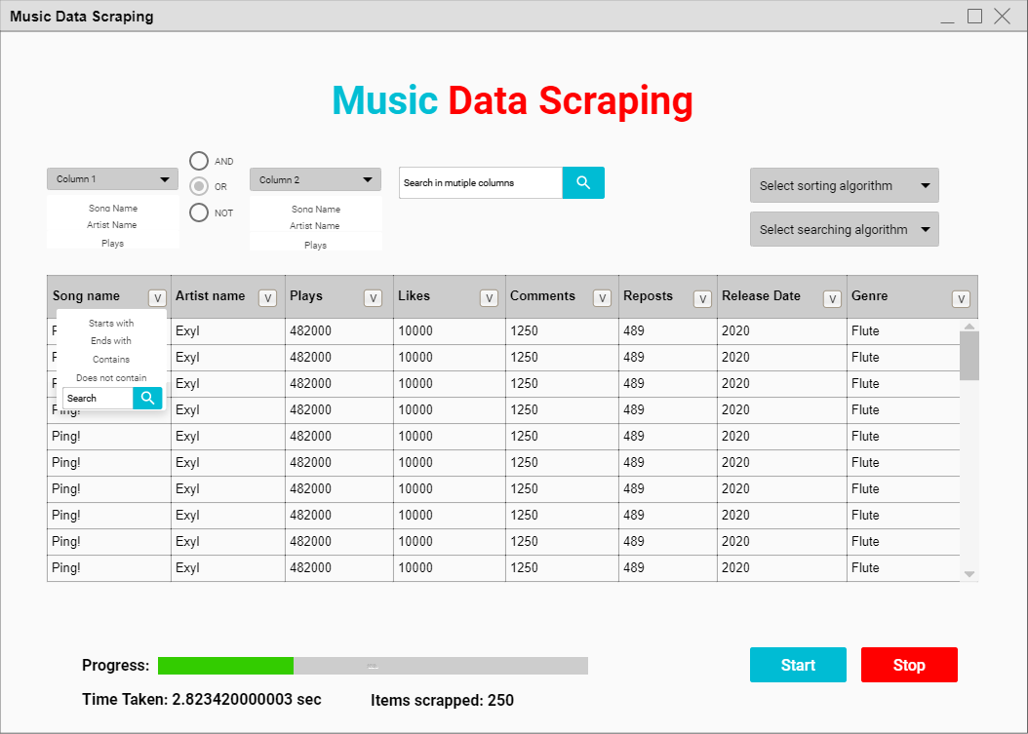

Figure : Initial GUI (Final Output may vary)

**Components**

The components are mentioned according to the final UI implementation:

1. Two similar Combo boxes for columns
2. Three Radio buttons for multi sorting
3. Two Textboxes for searching
4. Two Push buttons for searching
5. Two Push Buttons for both type of sorting
6. One checkbox for ascending and descending sorting
7. Two Combo boxes for filters and column to filter
8. One Table widget for displaying data
9. One Progress bar
10. Two Labels for items and time
11. Two Push buttons to start and stop
12. Two Combo boxes for searching and sorting algorithms

**Final UI implementation**

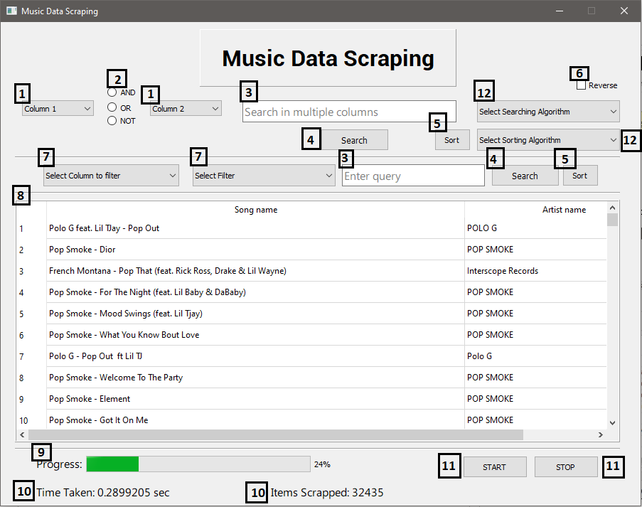

Figure : Final GUI Implementation

**5. Integration:**

**Problems while Integration**

Before integration, we faced a lot of problems during scrapping code, as SoundCloud is open to everyone, so anyone can upload content there. Apart from official creators, most of the uploaders had not added complete details about their songs. So, while scrapping, our scrapping code was retrieving none type data from the site, which took us much time to solve this issue.

On SoundCloud, the data is loaded as we scroll down the page, but our program was getting the first 10 loaded songs and was moving to the next page. We automate the Chromedriver to scroll down for a specific number of times, that’s how we solved this issue.

In the integration, we were unable to figure out that, how the PyQt environment works. Watched tons of tutorials videos, which became beneficial for us. Most importantly, the data loading part in Table. It was the irritating situation, didn’t find any good tutorial on internet. Got some help from a class mate, and we got successful in solving this problem.

While Search Filters integration, the data loading part was taking significantly much time, then we used the multi-threading technique to solve this problem.

**Overview of the whole working**

Starting from scrapping, we are using genres to search songs on SoundCloud. For this purpose, we have used another site as an API to scrap tons of genres, which is further used as a query on SoundCloud.

As told earlier, we were getting bogus data from SoundCloud, so we cleaned the data using different methods and functions, which you can see in Utilities.py / utilities.py file. After scraping, the data is stored in a CSV file.

We have created a UI of our project and then using the instance of the UI class to execute the app. After execution, an almost square size window appears, which shows the UI (like in above Figure 4). It shows a table with all songs, below the table, it shows the number of songs and besides there, it shows time taken by an algorithm. In start, it shows time taken by to load data in table.

The sorting combo box is used to select sorting algorithms and searching combo box is used to select searching algorithms and then we can select column from “Select column to filter” combo box for sorting. After sorting it shows the actual time taken by the algorithm. There is a checkbox which will be used for ascending/descending sorting.

There is also an option to filter to the data, whose procedure is that, we can select column from “Select column to filter” combo box and we can select filter from “Select filter” combo box and when we press the alongside available search button, we will get our filter results.

The start and stop buttons are used for live data scraping. When, we press the Start button, the scrapping starts in the backend, and when we press the stop button, the scraping get stop and the scrapped songs are displayed in the table

**6. Collaboration:**

In the beginning, both members worked together on the Project proposal. 2020-CS-31 designed the UI, and then implemented using PyQt5. 2020-CS-44 gathered the data about Sorting algorithms and 2020-CS-31 compiled the data into a word file. Moreover, 2020-CS-44 scrapped the data from the site. The implementing collaboration was almost zero throughout the project. Though, 2020-CS-31 alone programmed the project, as much as he can. At last, 2020-CS-31 formatted and gave this report its final shape. In short, the collaboration was bad throughout the project. The coding activity of both members can be seen through Github commits history:

<https://github.com/afzalashraf666/CS261F21PID43/commits/main>